Project Report on

Airline Management System

at

**U. V. Patel College of Engineering**



|  |  |  |
| --- | --- | --- |
| **Internal Guide:** | **Prepared By:** |  |
| Prof. Shishir Chauhan | Mr. Sneh Patel(19012021062) |  |
|  | Mr. Adarsh Patel (19012021039) |  |

**B.Tech Semester VI**

**(Computer Engineering/Information Technology)**

May-June, 2022

Submitted to,

Department of Computer Engineering/Information Technology

U.V. Patel College of Engineering

Ganpat University, Kherva - 384 012

##### **U.V. PATEL COLLEGE**

##### **OF**

**ENGINEERING**



**C E R T I F I C A T E**

# TO WHOM SO EVER IT MAY CONCERN

This is to certify that **Mr. Sneh Patel** student of **B.Tech Semester VI (Information Technology)** has completed his full semester on site project work titled “**Airline Management System”** satisfactorily in partial fulfillment of the requirement of Bachelor of Technology degree of Information Technology of Ganpat University, Kherva, Mehsana in the year 2021-2022.

|  |  |
| --- | --- |
| **Prof. Shishir Chauhan** | **Dr. Devang Pandya** |
| **College Project Guide** | **Head, Information Technology** |

## ACKNOWLEDGEMENT

This satisfaction that successful completion of any task would be incomplete without the mention of people whose ceaseless cooperation it made it possible, whose constant guidance and encouragement crown all efforts with success. We are grateful to our guide **Prof. Shishir Chauhan** for the guidance, inspiration and constructive suggestions that helpful us in the preparation of this project. We also thank our colleagues who have helped in successful completion of the project.

Mr. Sneh Patel

**ABSTRACT**

This project on **Airline management System** is the automation of registration of airline system. The system provides information like passenger’s information, flight information, list of all passengers, it allows storing and retrieving data related to the airline industry and make transaction related to air travel etc. The system also allows us to add records when a passenger reserves a ticket.

**INDEX**

1. INTRODUCTION 7
   1. Purpose 7
   2. Problem Statement 7
   3. Overview 7
   4. Objective 7
   5. Tools and Technology 7
2. FEASIBILITY STUDY 8
   1. Study of Current System 8
   2. Problem and weakened Of Current System 8
   3. Requirement of New System 8
   4. Technical Feasibility 8
   5. Economic Feasibility. 9
   6. Operational Feasibility. 9
   7. Requirement Validation. 9
   8. Feature of New System. 10
   9. Literature Survey 10
   10. Hardware and Software Requirement 10
   11. Project Planning 11
3. SYSTEM REQUIREMENTS STUDY 13
   1. Functional Requirement 13
   2. Non-Functional Requirement 13
4. SYSTEM DESIGN 14
   1. Use case 14
   2. Class Diagram 15
   3. Activity Diagram 16
   4. Sequence Diagram 17
   5. State Diagram 18
5. DATABASE STRATEGY 23
   1. Data Dictionary 23
6. CONCLUSION 25
7. REFERENCE 26

## INTRODUCTION

## Purpose

* This electronically handling of flight’s record to enhance the accuracy, flexibility, reliability

and to remove the human’s error.

* System provide accurate information about the addition, deletion and modified record.
* System provide, efficient, accurate, reliable, fast, and robust structure that can handle any

number of records.

## Problem Statement

* This project on Flight Management System is the automation of registration process of airline system. The system is able to provide much information like passenger’s details, flight details and the booking details. In this system available language. The system allows us to add records when a passenger reserves a ticket. It also allows to delete and update the

records based on passenger’s requirements.

## Overview

## This project shows you an insight into the management process of reservation in airline Management system. The whole process of Airline Management System is shown with the help of this project. It provides facility to add/Modify/Delete/search airline Management

* There are several ways to implement databases. Some of them are file handling mechanism, relational database, object-relational database or object-oriented databases.

## Objective

* To provide some amount of automation in airlines management.
* To help airlines system in making their business more efficient.
* It will also show the management so that customer are aware to the newly introduced

technology and ready to adopt them.

## Tools and Technology

* + - Java
    - Sqllite

## FEASIBILITY STUDY

## Study of Current System

* For the past few years we had see that number of people traveling is increasing rapidly, so people who travel by plane they find some difficulty to book tickets. This particular project deals with the problems

## Problem and weakened Of Current System

* Much time required in giving correct information.
* It is a time consuming process.
* Secrecy of information may not be maintained due to visible facts on paper.
* Manual procedure of providing information is not reliable.

## Requirement of New System

To remove problem of current system we require new system which has to fulfill the characteristic shown below.

* + - User Friendly
    - Make easy searching
    - Easy to change or update details
    - History

## Technical Feasibility

* The new system requires only 6 trained person to work with the system and in overall 10 people per office are sufficient. So we will identify 6 best people from existing system and train them.
* As our existing system is purely manual, so we need a one time

investment of Rs

4 Laks for the purchase of 7 computers, 5 Ticket printers, a laser printer,

AC and networking etc.

* It requires 20 Lacks PA as a operating cost. With the above details our

system is technically feasible as after investing 24 Lacks in a year, the

company is still saving Rs 25 Lacks PA.

## Economic Feasibility.

* With the manual system the operating cost of the system is about 60 Lacks P.A.
* This cost comprises salary of 25 people, stationary, building rent, electricity, water,

telephone etc. But with the new system this reoccurring cost comes out to be about

20 Lacks P.A. Hence the new system is economically feasible.

## Operational Feasibility.

* The new solution is feasible in all sence but operationally it is not. The new system

demands the expulsion of at least 15 people from the company.

* It creates an environment of joblessness and fear among the employees.
* It can lead to an indefinite strike in the company also. So the management

must take corrective actions prior in advance in order to start the further proceedings.

## Requirement Validation.

### ADMINISTRATOR MODULE :-

In administrator module administrator manages the master data’s like server details and flight details.

### USER MODULE :-

In user module, they can book flight, change flight, can check flight status.

### EMPLOYEE MODULE :-

The employee module consist of data related to the employee who are registered to the flight. Admin can manage and modify profile of an employee.

## Feature of New System.

* Allow passengers to choose their seats.
* Notification through email regarding ticket bookings, cancellation and

flight delayed, etc.

* Easy to download boding pass at home
* Track flight while travel

## Literature Survey

* Less reliability and maintainability of data.
* Secrecy of information may not be maintained due to visible facts on paper.
* Much time required in giving correct information.
* Manual procedure of providing information is not reliable.

## Hardware and Software Requirement

* **Hardware Requirement**
  + Processor : Intel Core i5
  + Processor speed : 1.4 GHz Onwards
  + RAM : 8 GB
  + Hard Disk : 1 TB
  + Device : Laptop / Desktop

## Software Requirement

* + Operating System : Windows 10
  + IDE : Android Studio
  + Frontend : Java
  + Backend : SQL-Lite

## Project Planning

* **Log in/Sign up:**

User can Log in this site. If user is new then Sign up and then Log in into site.

## Manage Flight :

Admin can add new flight and also update & delete flight.

## Payment:

User can pay ticket payment using debit card, credit card.

## Update/Delete Flight:

Admin can update Flight details and status if there any changes like change time etc. Admin can also delete flight details.

## Payment status:

Here it checks the full details of Customer paid Payment

## Add Employee:

Admin can add new employee with full details and designation to becoming a staff member.

## Update / Delete Employee:

Admin can update employee details and designation with working status if their any changes and also delete employee details.

## Employee Payment:

Here it display the salary given to employee with full details and also remaining salary.

## Employee Details / Leaved Employee :

In this it display all the employee working in this hostel with full detail and also display the leaved employee Details.

## 3. SYSTEM REQUIREMENTS STUDY

## Functional Requirement

* New Registration
* Edit Personal Details
* Login/Logout Account
* Search Flight
* Book ticket
* Make Payment
* Cancel Ticket
* E-mail Confirmation

## Non-Functional Requirement

* Accessibility
* Privacy
* Security
* Reliability
* Response time
* Robustness
* Supportability
* Scalability

## SYSTEM DESIGN

## Use case

## 

## Class Diagram

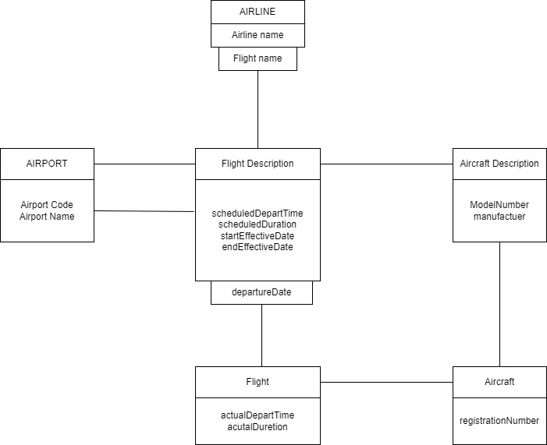

## Activity Diagram

## 

## Sequence Diagram

## 

## State Diagram

## 

**5.DATABASE STRATEGY**

## 5.1 Data Dictionary

**Table 1 – Login**

Description – This table show Login data.

|  |  |  |  |
| --- | --- | --- | --- |
| ***Column*** | ***Type*** | ***Null*** | ***Comment*** |
| *id* | *varchar(50)* | *No* | *Login id* |
| *password* | *varchar(50)* | *No* | *Login Password* |

**Table 2 – Flight Add**

Description – This table show Flight Add data.

|  |  |  |  |
| --- | --- | --- | --- |
| ***Column*** | ***Type*** | ***Null*** | ***Comment*** |
| *FlightName* | *Varchar(20)* | *No* | *Flight Name* |
| *FlightTime* | *Number(10)* | *No* | *Flight Time* |
| *Departure* | *String* | *No* | *Flight Departure* |
| *Arrival* | *String* | *No* | *Flight Arrival* |

**Table 3 – Flight Book**

Description – This table show Flight Book data.

|  |  |  |
| --- | --- | --- |
| ***Column*** | ***Type*** | ***Null*** |
| *FlightName* | *Varchar(10)* | *No* |
| *FlightTime* | *Number(10)* | *No* |
| *FlightPlace* | *Varchar(20)* | *No* |
| *Trip Type* | *Varchar(20)* | *No* |

**Table 4 - Profile**

Description – This table show Profile data.

|  |  |  |
| --- | --- | --- |
| ***Column*** | ***Type*** | ***Null*** |
| *FirstName* | *String* | *No* |
| *LastName* | *String* | *No* |
| *Email* | *Varchar(20)* | *No* |

**ScreenShort:**

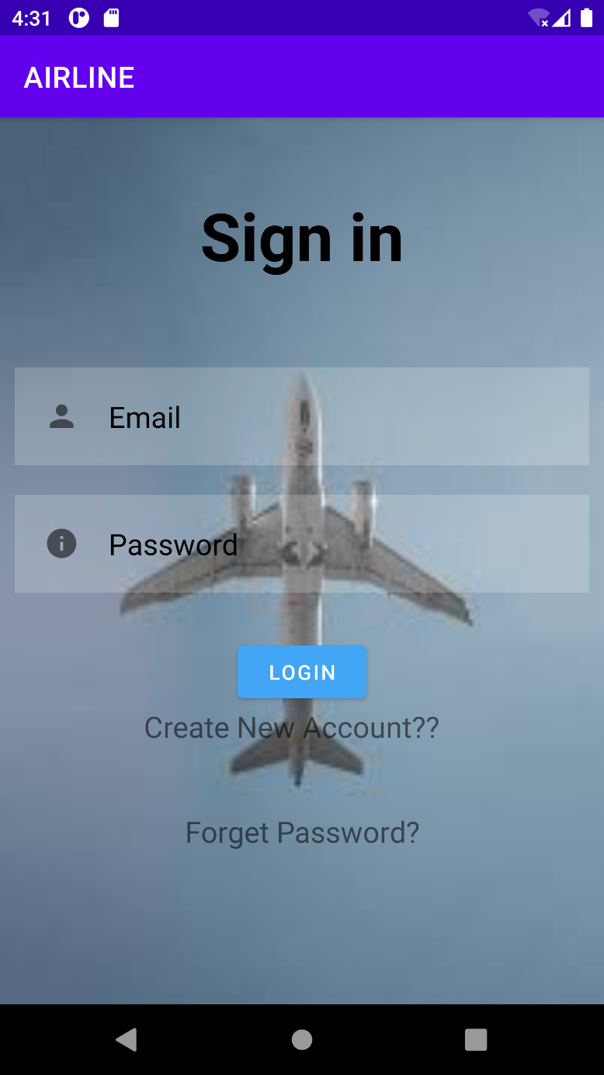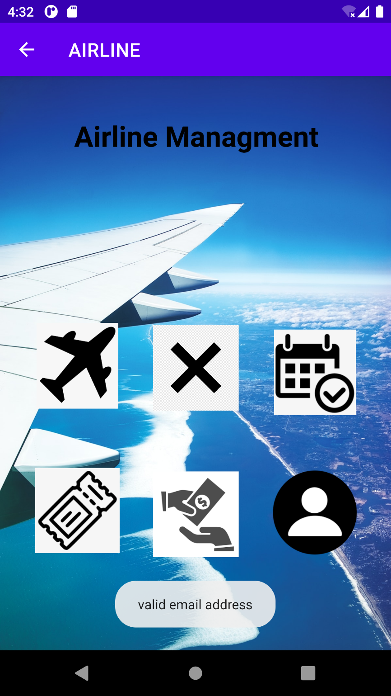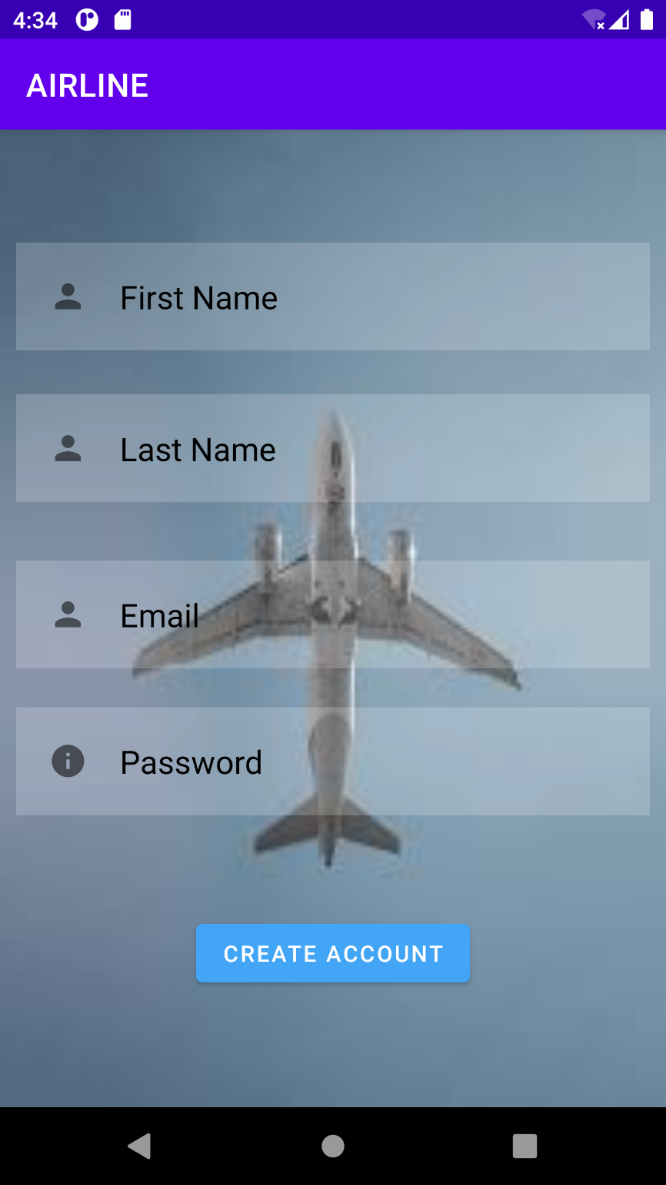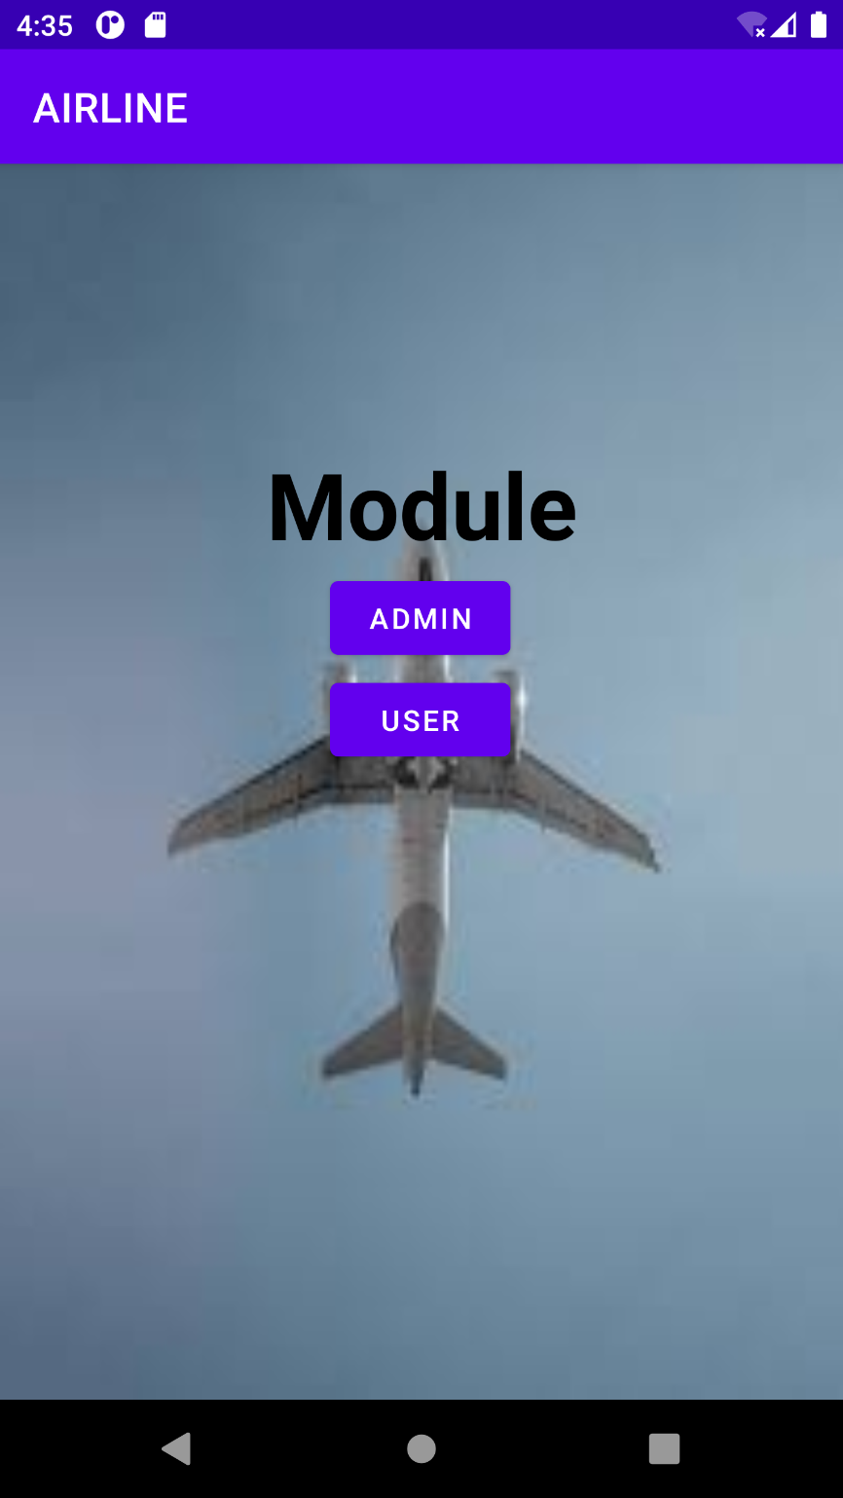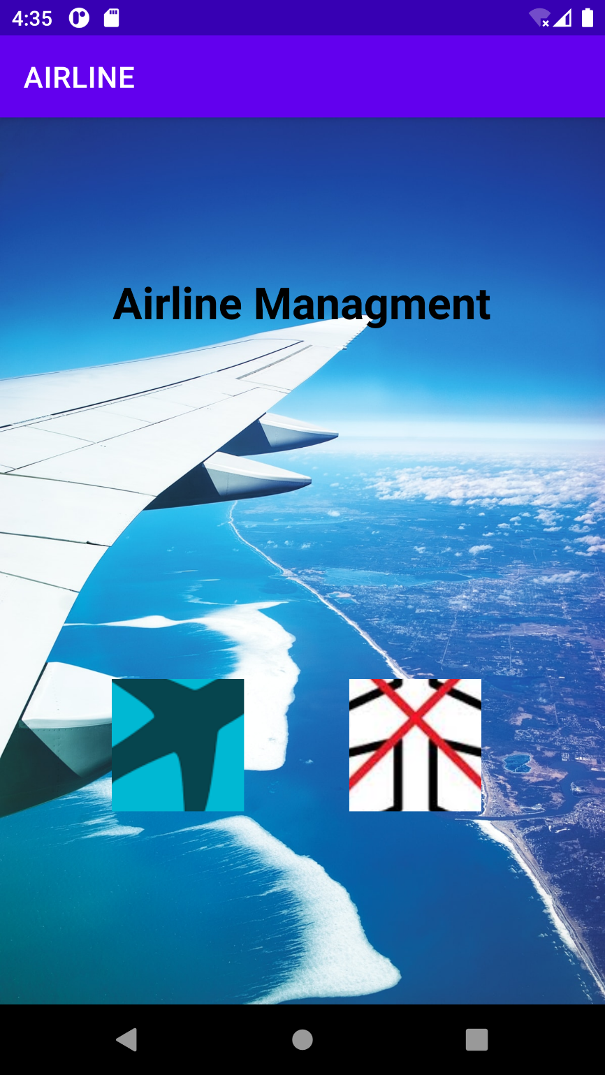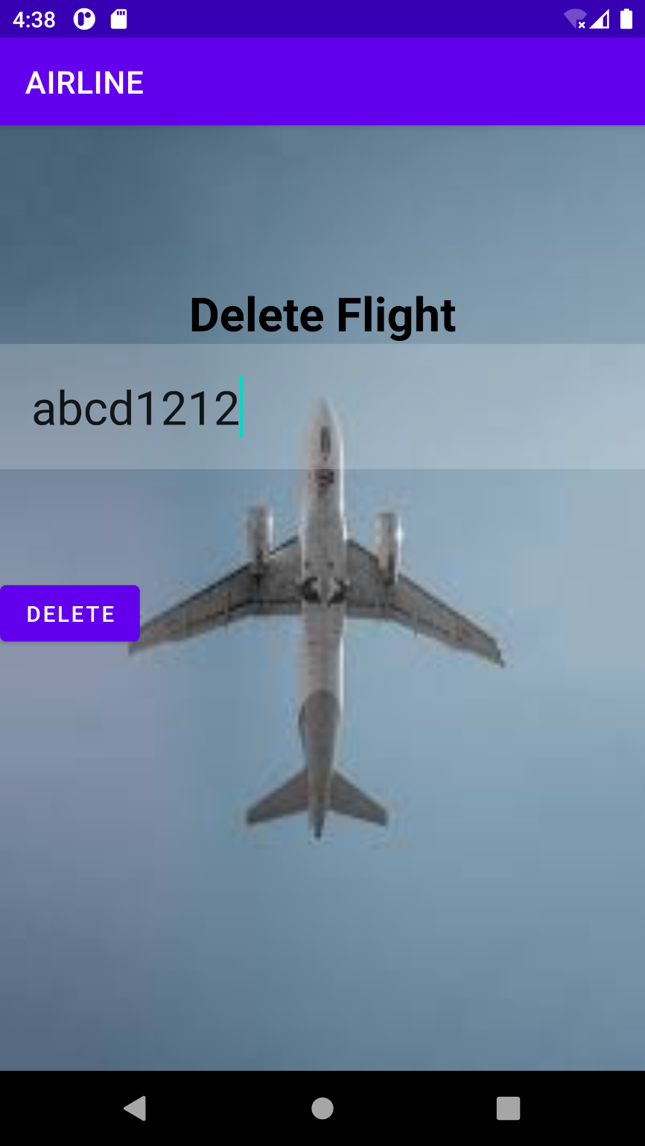

## 

## 6.CONCLUSION

This project on Airline Management System is the automation of registration process

of airline system. The system is able to provide much information like passenger’s

details, flight details and the booking details. The system allows us to add records

when a passenger reserves a ticket. It also allows to delete and update the records

based on passenger’s requirements. This project has guided our path through various aspects of computer science where developing online application plays a major role.

## 7.REFERENCE

[1]<https://developers.openshift.com/database/mysql.html>

### [2] Web References- https://youtu.be/UbIIFLsEeiM